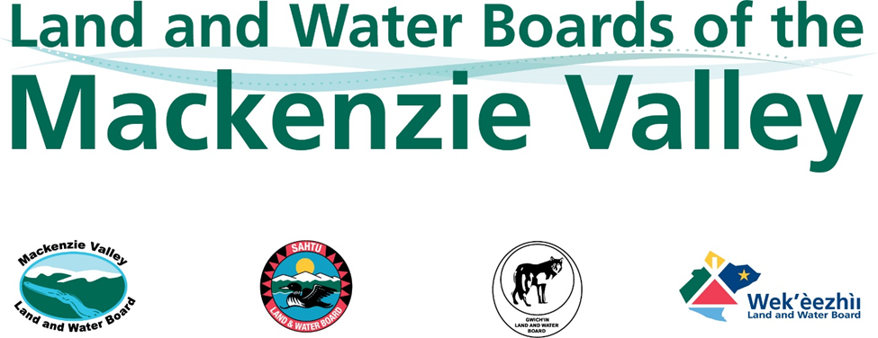

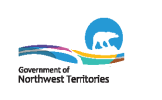

Method for Determining Available Winter Water Volumes for Small-Scale Projects

April 27, 2020

Introduction
The Land and Water Boards of the Mackenzie Valley (Boards) regulate the use of land and water and the deposit of waste within the Mackenzie Valley through the issuance of land use permits and water licences. In order to ensure proposed water uses would not adversely affect existing users or the environment, the Boards require information regarding proposed water sources, including the location, timing, and proposed volume of water to be used. An existing Fisheries and Oceans Canada (DFO) Protocol for Winter Water Withdrawal from Ice-covered Waterbodies in the Northwest Territories and Nunavut (the DFO Protocol) developed in 2010 requires water users to complete bathymetric surveys of most water bodies to calculate under-ice water volumes prior to determining acceptable winter water use limits, i.e., no more than 10% of the total remaining under-ice volume. This 10% remaining volume is a maximum for all existing and proposed water-use activities per ice-covered season. If there are multiple users using the same source, the total withdrawal must not exceed 10% of under-ice volume. The Boards recognize and promote the DFO Protocol as the best practice. Because detailed bathymetric methods require expertise and effort that may not align with the early stages or scope of smaller projects, though, the Boards and the Government of the Northwest Territories Department of Environmental and Natural Resources (GNWT-ENR) have developed this alternative standard approach.
This Method has been developed for type B Water Licence applicants of early stage exploration or other limited scope projects to conservatively estimate available under-ice water use limits from water sources in the absence of bathymetric data and to confirm limits in the field. The removal of excessive water under ice cover conditions could lead to oxygen depletion that may impact any over-wintering fish. The DFO Protocol remains the recommended standard for most larger scale developments, as bathymetric data is more accurate and may subsequently provide for more water to be used. This method, developed by the Boards and GNWT-ENR, can be adapted to the open-water season to maintain protection of the aquatic environment. Since fish and aquatic environments are potentially less sensitive to open-water withdrawals compared to ice-covered conditions, alternative approaches accompanied by supporting rationale may be considered.
Parties were invited to provide submissions recommending alternate approaches for estimating conservative under-ice water volumes in October 2019. A follow-up meeting was held in February 2020 to discuss the submissions received and other alternatives identified through a literature review. The submissions were tested against water sources with measured water volumes for their ability to provide accurate and protective estimates of water volumes in ice-covered waterbodies using the same protective assumptions and criteria identified in the DFO Protocol. Further background on the derivation of this method is included in the accompanying Technical Reference Document.
Submission Requirements
When providing estimates of available capacity of proposed water sources without detailed bathymetry, applicants must provide the following to the Board:
- Water Use Estimate
- A map and table identifying all proposed water sources, providing geographic coordinates and Total Surface Area calculations;
- Description of how Total Surface Area was calculated;
- A calculation for Total Available Water Use for each proposed water source:
Total Surface Area (SA, m²) * 0.10 m = Total Available Water Use (m³).
- The total amount of water being proposed for use from each source; and
- Acknowledgement of applicable DFO intake screen guideline(s) (DFO, 2011; DFO, 2020).

Table 1: Water Use Calculation Table
Waterbody ID | Calculated Surface Area (m²) (SA) | Total Available Water Use (m³) (SA*0.1 m) | Comparison of Proposed Annual Water Use to Estimated Available Use (m³)
e.g., 1 | 45,000 | 4,500 | Any amount ≤ 4,500

- Field Verification Plans
- Using assumed ice depths based on location in the NWT as identified in the DFO Protocol (see Table 2), provide a description of field verification plans or results demonstrating that under-ice water depth is, at minimum, 1.5 m. This must be measured in at least three locations >20 m from shore and approximately 20 m apart; and
- A description of field verification plans for tracking water use to ensure water volume limits are not exceeded.

Table 2: Assumed Ice Depths by Location
Region |  | Maximum Expected Ice Thickness (m) | Minimum Waterbody Depth Required* (m)
Map | North NWT:  Above the Tree Line | 2.0 | 3.5
 | Mid NWT:  Fort Simpson to the Tree Line | 1.5 | 3.0
 | South NWT:  Dehcho – South of Fort Simpson | 1.0 | 3.0
*Minimum water body depth is equal to the maximum expected ice thickness plus 1.5 m of water below the ice, or 3.0 m, whichever is greater.

Rationale
The Boards and GNWT-ENR consider the above approach to be conservative for the following reasons:
- The DFO Protocol statistically estimated maximum ice thicknesses using long term data from Environment Canada: Water Survey of Canada and Canadian Ice Services, which are maximum thicknesses based on field observations (Cott et al. 2005);
- The 10% maximum allowable under-ice water volume supported the DFO Protocol was established based on field observations with no effects measured on fish or fish habitat (Cott et al. 2008);
- Lakes with an average depth of 2.7 m have been demonstrated to remain below the available 10% withdrawal limits using the 10 cm water taking calculation method described above (see the accompanying Technical Reference Document for more). This threshold was increased to 3 m;
  - The 10 cm withdrawal calculation presented above protected 100% of lakes with an average ice-free depth exceeding 2.7 m (see Figure 1);
  - All viable waterbodies must have an average water depth under ice of ≥ 1.5 m in addition to a total average depth of ≥ 3m.
- The recommended 10 cm loss in total water depth represents a conservative acceptable measurement derived from the following:
  - Losses of 18 cm water depth have been demonstrated to remove approximately 10% of available under ice water volume (Golder, 2018);
  - One standard deviation (6 cm) was subtracted and then rounded down again (from 12 cm to 10 cm) as an extra degree of precaution.
- Not all lakes will have fish; and
- It assumes no winter inflow to replenish lake volume and/or oxygen reserves.
Supporting Dataset
Bathymetric data sets from the Back River project and the Tibbitt to Contwoyto Ice Road showed the conservatism of the calculated 10 cm surface water drawdown against lakes with detailed bathymetry with known under ice water volumes. More details on the datasets used to support this Protocol are provided in the accompanying Technical Reference Document (reference).
Figure 1: 10 cm water use removed <10% of the under-ice volume in lakes with average depth >2.7 m. 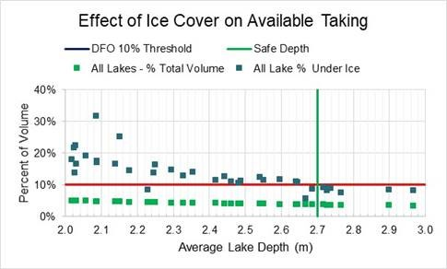

Hutchinson Environmental Sciences Limited, 2020. Technical Reference Document for the Method for Determining Available Winter Water Volumes for Small-Scale Projects.
Full references available in Hutchinson Environmental Sciences Limited, 2020. Technical Reference Document for the Method for Determining Available Winter Water Volumes for Small-Scale Projects.
Cott, Peter A., Paul K. Sibley, W. Murray Somers, Michael R. Lilly, and Andrew M. Gordon, 2008. A Review of Water Level Fluctuations on Aquatic Biota With an Emphasis on Fishes in Ice-Covered Lakes. Journal of the American Water Resources Association (JAWRA) 44(2):343-359. DOI: 10.1111/j.1752-1688.2007.00166.x.

